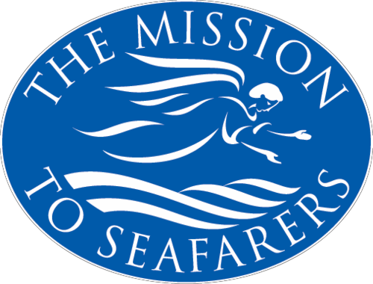

**FALL LUNCHEON**

# THURSDAY OCTOBER 21st

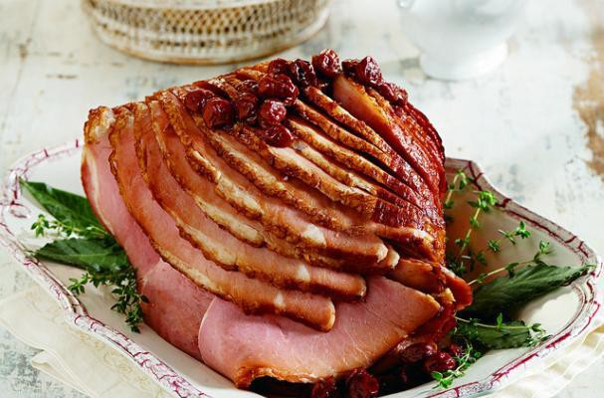**Take Out**

Ham, hashbrown casserole,

Baked beans &

Dessert

$12.00

**Please** Order By October 14th (902) 422- 7790

[hglenn@missiontoseafarershalifax.ca](mailto:hglenn@missiontoseafarershalifax.ca)